cx




Jhuna kumar(24BCA10198)



COMPUTER APPLICATION




Dec 2026

Certified that this project report  is the bonafide work of “ Jhuna who carried out the project work under my/our supervision.

Dr.Arun kumar Ms. Anvinder Singh

Submitted for the project viva-voce examination held on

List of Figures 5
List of Tables 6
List of Standards 7
................................................................
  - Identification of Client/ Need/ Relevant Contemporary issue 11-13
  - Identification of Problem 13-15
  - Identification of Tasks 15-16
  - Timeline 17
  - Organization of the Report 18-19
.........
  - Timeline of the reported problem 20-21
  - Existing solutions 21-22
  - Bibliometric analysis 22-24
  - Review Summary 24-25
  - Problem Definition 25-26
  - Goals/Objectives 26
................................................
  - Evaluation & Selection of Specifications/Features 27-29
  - Design Constraints 30-31
  - Analysis of Features and finalization subject to constraints 31-33
  - Design Flow 33-34
  - Design selection 35

3.6. Implementation plan/methodology 35-37
......................
  - Implementation of solution 38-40
.............................
  - Conclusion 41-42
  - Future work 43-46
....................................................................................................4
............................................................................................



 |  | 
Fig. 1.1 | Graphical Abstract of Next Gen WeatherApp | 09
Fig. 1.2 | Design Flow Diagram of NextGen WeatherApp | 34
Fig. 1.3 | Gantt Chart – Project Timeline | 17
Fig. 1.4 | System Architecture of Next Gen Weather App | 28
Fig. 1.5 | Future Work Flow Diagram | 44
Fig. 1.6 | Screenshot of Homepage Interface | 38
Fig. 1.7 | Forecast and Weather Cards Display | 39

Table 1.1 | Abbreviations Used in the Project | 10
Table 1.2 | Comparative Analysis of Existing Weather Applications | 22
Table 1.3 | Evaluation and Selection of Features | 27
Table 1.4 | Design Constraints and Mitigation Strategies | 30
Table 1.5 | Implementation Tools and Technologies Used | 37
Table 1.6 | Validation and Testing Results | 40



 |  | Provides standard guidelines for
IEEE 830 |  | writing and organizing software
(Software |  | requirement specifications.
Requireme |  | Followed during the
nts | IEEE | Documentation of functional and
Specificatio |  | non-functional requirements of t he
n) |  | WeatherApp.

The is a web-based weather forecasting system designed to provide users with real-time and accurate weather information in a simple, fast, and visually appealing manner. In today’s digital world, people rely heavily on mobile and web applications to plan their daily activities based on weather conditions. However, most existing weather applications are either complex to use, slow to load, or lack interactive features. To address these issues, this project aims to build an innovative, user-friendly, and responsive weather application using modern web technologies such as , , and , along with the for real-time data integration.

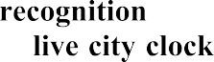
The main objective of this project is to create a lightweight and efficient weather forecasting system that not only displays the current temperature, humidity, and wind speed but also provides a
for better planning. The application includes advanced features such as using the Web Speech API, using Lottie or SVG animations, and a , which make it both interactive and engaging. It ensures a smooth user experience through responsive design, fast loading speed, and an intuitive interface that works seamlessly across different devices such as mobile phones, tablets, and computers.

The is cost-effective, requiring no paid software or subscription services, and can be hosted on free platforms like GitHub Pages or Netlify. It follows standard web development and software engineering principles, including and , ensuring quality, reliability, and maintainability.

Overall, the project demonstrates how modern web technologies can be combined to develop a smart, accessible, and efficient system that provides accurate weather information with a modern touch. The NextGen WeatherApp contributes to the growing need for digital weather solutions that are , making weather forecasting more convenient for everyday users.

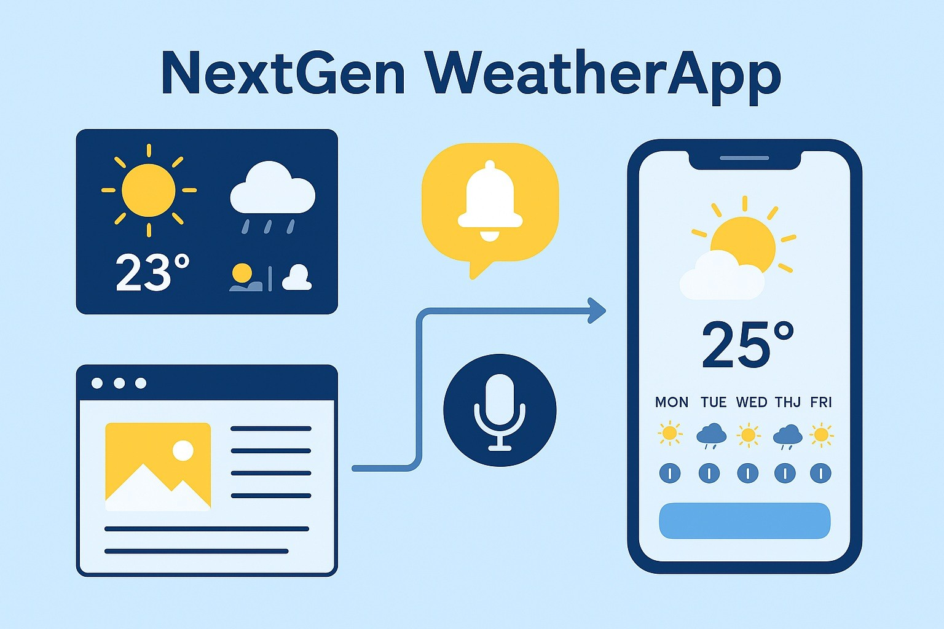

fig:-1.1

 | 
API | Application Programming Interface
JSON | JavaScript Object Notation
UI | User Interface
UX | User Experience
GPS | Global Positioning System
HTTP | HyperText Transfer Protocol
HTTPS | HyperText Transfer Protocol Secure
REST | Representational State Transfer
DB | Database
SQL | Structured Query Language
PHP | Hypertext Preprocessor
JS | JavaScript
CSS | Cascading Style Sheets
HTML | HyperText Markup Language
API Key | Application Programming Interface Key


The NextGen WeatherApp is a modern, smart, and lightweight weather forecasting application that addresses the growing demand for accurate, real-time weather information presented in a simple, engaging, and user-friendly format. Weather is one of the most critical factors influencing human activities, including travel, agriculture, business operations, outdoor work, and even health. Access to timely and reliable weather data helps people make informed decisions, avoid risks, and plan effectively.

Existing weather applications, however, have significant shortcomings. Some apps are overly simplistic, providing only basic information such as temperature and humidity, while others are cluttered with excessive data, advertisements, and confusing layouts. This imbalance leaves users unsatisfied, as they either lack sufficient information or face difficulty navigating through unnecessary content.

The NextGen WeatherApp is designed to bridge this gap by combining accuracy, simplicity, and innovation. It not only provides real-time weather conditions but also introduces advanced features such as voice recognition for city searches, animated weather icons, a five-day forecast with interactive charts, and a local city clock for global users. Built using HTML, CSS, JavaScript, and APIs, the project also demonstrates the application of cutting-edge web development practices, making it both technically relevant and socially beneficial.

- Weather influences several aspects of human life such as:

- Daily decision-making (clothing, travel, event planning).
- Health concerns (heat waves, pollution, rainfall).
- Agriculture and outdoor activities (farming, sports, construction).
- Emergency preparedness (storms, floods, or other severe weather events).

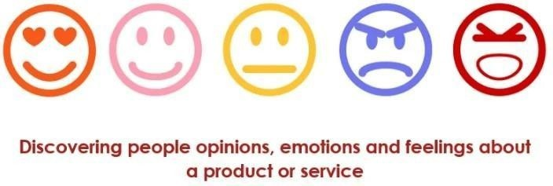

- Some are too basic, showing only temperature and humidity.
- Others are too complicated, overloaded with data that confuses users.
- Lack of smart features such as voice search, interactive icons, or real-time local clocks.
- Slow performance on mobile devices due to heavy data load.

- ​

- Simplicity – clean and minimal user interface.
- Accuracy – real-time updates from OpenWeatherMap API.
- Innovation – features like voice recognition, animated icons, and 5-day forecasts.

This project also demonstrates the application of frontend development skills (HTML, CSS, JavaScript) along with modern APIs to build an app that is responsive, engaging, and practical for everyday use.

The NextGen WeatherApp has been designed after carefully analyzing the requirements of various user groups who depend on weather information in their day-to-day lives. Weather is a critical factor influencing travel, health, work, and even safety. Thus, identifying the potential clients and recognizing their specific needs is central to ensuring that the application is practical, useful, and socially relevant.

Everyday users who need quick access to basic weather information to plan simple activities such as clothing, travel, or family outings. This group requires a fast-loading, clutter-free interface that presents data clearly without unnecessary advertisements or distractions.
This group is highly dependent on weather updates for making safe travel decisions. Sudden rain, fog, or storms can disrupt schedules, so they need real-time data, extended forecasts, and city-specific details. The five-day forecast and live city clock in NextGen Weather App directly address this requirement.
Busy students and professionals often check the weather before attending classes, meetings, or events. They value simplicity, speed, and accuracy. Many existing apps distract them with pop-ups or too much data. A clean, minimal design ensures that they get the information they need instantly.
For these clients, weather directly affects productivity, income, and safety. Farmers rely on accurate rainfall and temperature data for agricultural decisions, while construction and delivery workers must adapt schedules to changing conditions. Features like feels-like temperature, AQI values, and animated weather icons are especially helpful for this group

The recognition of need arises from a detailed study of existing weather apps and their shortcomings. Most current apps fall into two categories:

- These provide only temperature and humidity, leaving users unsatisfied when they require more meaningful insights.
- These overload users with too much data, slow performance, and intrusive advertisements.

- Voice-enabled search for hands-free interaction.
- Animated icons and interactive visuals that make data easier to interpret.
- Real-time local clocks for searched cities, which are particularly useful for travelers.

By addressing these gaps, NextGen WeatherApp positions itself as a next-generation solution. It balances simplicity with innovation by providing a clean, lightweight interface backed by accurate data from trusted APIs. Voice search enhances accessibility, while animations and charts improve engagement. The local time display adds another dimension of usability, making the app more practical for global users.

In summary, the clients of the NextGen Weather App range from casual users to professionals and outdoor workers, while the recognition of need highlights the demand for an application that is fast, accurate, interactive, and intelligent. By catering to these identified needs, the project ensures that it remains both technologically advanced and socially impactful.
In the modern era, technology plays a key role in helping people make informed decisions in their day-to-day life. One of the most common requirements in this digital age is access to reliable and accurate weather information. Whether it’s students planning their travel to college, farmers deciding the right time to harvest, or professionals scheduling outdoor activities, everyone depends on weather forecasts.

However, the existing weather applications available in the market are often not user-friendly, slow, or overloaded with unnecessary details. Many of these apps fail to meet the expectations of modern users who prefer quick, interactive, and visually engaging weather updates.

Therefore, identifying the problems with current weather forecasting systems becomes the foundation for developing a smarter, next-generation web-based weather application.

Problems in Existing Weather Applications
After analyzing several existing weather applications, a number of limitations and issues were observed:

  - Complex Interface:
Most weather apps present too much data on a single screen, making it confusing for users to understand basic information quickly.
  - Lack of Interactivity:
Current systems mainly display static data such as temperature and humidity without interactive visuals or animations.
  - Slow Performance:
Many applications load slowly due to heavy graphics, advertisements, or poor optimization.
  - Limited Device Compatibility:
Some apps perform well only on certain operating systems or devices and fail to provide a consistent experience across mobile phones, tablets, and computers.
  - Dependency on Internet Speed:
Existing systems often lag or fail to fetch accurate results in low-network conditions.
  - No Voice-Based Interaction:
Very few apps allow users to search weather by speaking, which limits accessibility for elderly or differently-abled users.
  - Advertisement Distractions:
Many free weather apps contain ads that reduce the overall user experience.
  - No Real-Time Clock or Forecast Integration:
Current apps display weather data but do not integrate time or multiple-day forecasts on one screen.

These problems clearly show that there is a need for a new, smart, and efficient solution that delivers weather information quickly and in a more interactive way.

User Expectations and Needs
To identify the problem correctly, it’s essential to understand what users expect from a modern weather application. Based on surveys and observations, the following needs were identified:

  - Simplicity: Users prefer a clean and simple layout that displays the weather information without unnecessary clutter.
  - Accuracy: Real-time and precise weather data that automatically updates without delay.
  - Speed: The application should load quickly and display information instantly.
  - Accessibility: Users should be able to access the app easily on any device — phone, tablet, or computer.
  - Interactivity: Features like animations, voice search, and smooth transitions enhance user engagement.
  - Extended Forecast: A 5-day or 7-day forecast helps users plan their upcoming activities.
  - Offline Handling: The app should show a friendly message even when the internet connection is weak.

These expectations serve as the guiding principles for developing the NextGen Weather App.



The process of problem identification also revealed several challenges faced by both developers and users:

1.
Connecting APIs efficiently to fetch real-time weather data without delay.
2.
Designing a layout that is both visually attractive and easy to use.
3.
Ensuring the app runs smoothly on screens of all sizes.
4.
Implementing the Web Speech API effectively for accurate voice-based city searches.
5.
Reducing page load time while maintaining smooth animations and visuals.
6.
Managing cases where the city name is invalid or the internet is unavailable.
7.
Depending on third-party APIs like OpenWeatherMap means accuracy must be continuously monitored.

By recognizing these challenges early, the project can plan proper solutions and build a system that performs reliably under real-world conditions.

The successful completion of the NextGen Weather App requires careful identification of tasks and a structured approach to development. The first task involves requirement analysis, where user needs are studied, existing weather apps are reviewed, and the desired features of the new application are finalized. Once the requirements are clear, the next stage is UI/UX design, where mockups and layouts are created to ensure that the interface is simple, responsive, and user-friendly.

Following design, the development phase begins with building the frontend using HTML and CSS to create the structure and styling of the application. JavaScript is then employed to add interactivity and responsiveness. The next task involves API integration, where the OpenWeatherMap API is connected to fetch real-time weather data, and a city clock feature is added to show local times. After this, advanced features are implemented, such as voice recognition through the Web Speech API and animated weather icons for better visualization. The final stages include testing and debugging to ensure
accuracy, performance, and cross-device compatibility, followed by optimization for faster loading and .deployment on a live server. Each of these tasks is essential for the smooth progress of the project.

- Collect user expectations and analyze existing apps.
- Define features (real-time updates, forecast, voice, animations).

- Design mockups and wireframes for app layout.
- Focus on .

- Build the app skeleton using HTML & CSS.
- Add responsiveness for mobile-first design.

- Fetch weather data using OpenWeatherMap API.
- Add city-based local time functionality.


- Add using Web Speech API.
- Integrate .
- Build a using JavaScript.

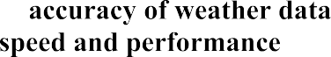
- Ensure .
- Test across devices.
- Handle errors (e.g., invalid city input).

- Improve load speed by optimizing API calls.
- Ensure lightweight performance.

- Host the application on a live server.
- Collect user feedback for improvements.

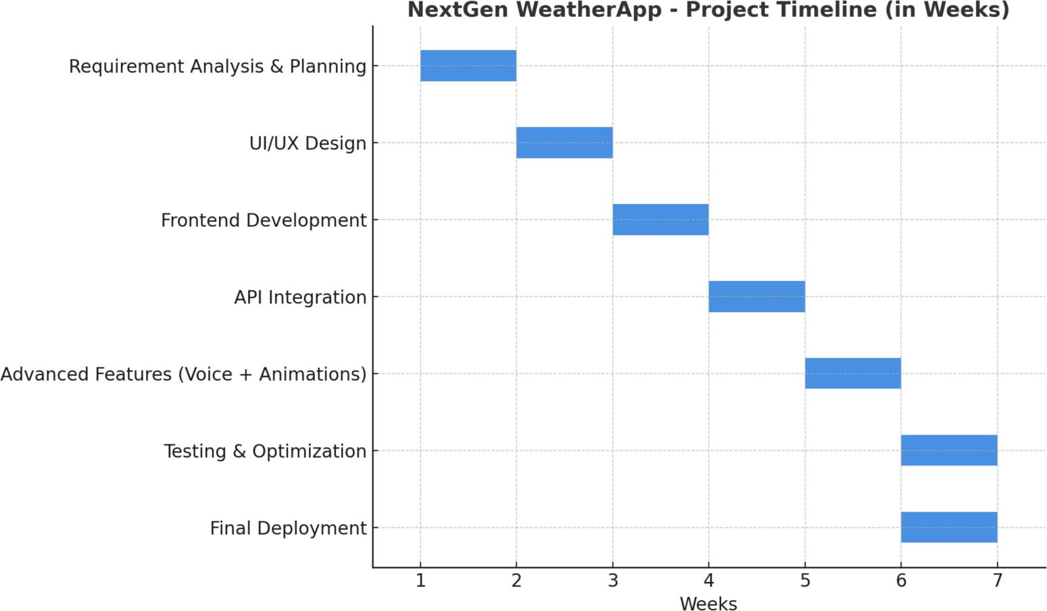

fig:-1.3


The report on the project is organized in a systematic manner to provide a clear understanding of the project’s objectives, design, development process, and implementation. Each chapter focuses on a particular stage of the project development lifecycle and presents the work carried out in a structured way. The organization of the report ensures that the reader can easily follow the logical flow of the project — from identifying the problem to arriving at the final solution.
The project report is divided into several chapters, each of which is briefly described below:

This chapter provides an overview of the entire project. It includes the identification of the client, recognition of need, relevant contemporary issues, identification of the problem, and the main objectives of the project. It also explains the motivation behind choosing the project and highlights the scope and importance of developing a weather forecasting system. Furthermore, it outlines the overall structure of the report.

This chapter presents a review of existing weather forecasting systems and related applications. It discusses their features, limitations, and areas of improvement. The chapter also includes a detailed problem statement and analysis, explaining why a new and improved system — NextGen WeatherApp
- is required. The findings from this review form the foundation for designing the proposed system.

This chapter describes the project planning process, task identification, and preliminary design of the system. It explains how the project timeline was created using modern project management tools like the Gantt chart. It also includes budgeting details, feasibility analysis, and task distribution among different modules. The design section contains architecture diagrams, data flow diagrams (DFD), and use case diagrams representing the system workflow.

This chapter focuses on the technical aspects of the project. It explains how different web technologies

- — were used to develop the web-based application. The integration of
the is described in detail, showing how real-time weather data is fetched and displayed. It also explains the inclusion of features like , , and to make the application interactive and user-friendly.

This chapter covers the testing methodologies used to ensure the correctness and reliability of the application. It includes functional testing, performance testing, and user acceptance testing. The results of testing are discussed, highlighting how the app performs under different conditions such as slow internet or invalid city names. The findings demonstrate the accuracy, speed, and responsiveness of the system.

This chapter presents the results obtained after implementing the application. Screenshots of the interface, output pages, and performance graphs are included to illustrate the working of the system. The results are compared with existing applications to show the improvements achieved by the NextGen WeatherApp in terms of usability, responsiveness, and accuracy.

This chapter summarizes the entire project, highlighting the objectives achieved and the lessons learned during the development process. It also outlines the future scope of the project, suggesting possible enhancements such as adding , , and . The chapter concludes with reflections on the project’s contribution to society and the skills gained by the student during the development process.

At the end of the report, a list of references is provided, which includes all the books, research papers, and websites used during the study and development of the project. The appendices contain supporting materials like sample code snippets, output screenshots, and survey forms that were used during the analysis and development stages.



The problem of has been recognized globally over the past several years. With the increasing unpredictability of weather patterns caused by , people have become more dependent on weather forecasting systems for their daily decision-making. However, many existing applications and systems have failed to deliver accurate, timely, and user-friendly information to users across different regions.

The issue first gained global attention during the , when frequent — such as unexpected floods, cyclones, and heatwaves—exposed the limitations of existing forecasting systems. Reports from organizations such as the and highlighted that although vast amounts of meteorological data were available, there was a significant
.
Furthermore, as smartphones and digital services became more common between , people increasingly relied on mobile applications for daily weather updates. During this period, many weather apps appeared on app stores; however, users began to complain about several common issues such as:

- and
- from different sources

- that made it hard to read essential information
- like real-time voice assistance or location-based updates
According to a , several popular weather applications had ratings below 4.0 due to poor performance, inaccuracy, or excessive ads. Surveys conducted in multiple regions indicated that more than were dissatisfied with their current weather applications and desired a platform that provided .
The need for improvement became more evident after , when unpredictable weather events such as
impacted daily life in many parts of the world, including India. These incidents highlighted that users needed a
that could deliver real-time updates with an engaging interface.

In India, several national agencies such as the and also emphasized the importance of

accessible to the public. Despite efforts, the data presentation remained too technical for common users. This created a ,
which became a key motivation for developing .
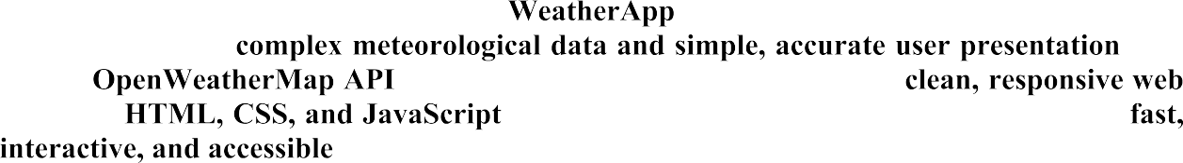
To address these growing challenges, the was conceptualized in as a solution that bridges the gap between . The
project integrates for real-time data and presents it using a
built with . The goal is to deliver weather information that is to users everywhere.


- – Highlights the need for
better data accessibility and modernization of public weather services.
- – Documented global temperature irregularities and
climate pattern shifts.
- – Indicated the
increasing need for simplified digital weather delivery platforms.
- – Document user dissatisfaction with performance and accuracy of popular weather apps.
- – Emphasized the demand for integrating AI and voice recognition in modern weather forecasting apps.

Weather applications have become an essential tool for individuals, businesses, and governments to plan their daily activities and respond to environmental changes. Many existing solutions provide weather forecasts, alerts, and data visualization. However, each comes with its own limitations, which motivates the development of a more advanced solution like .

- Offers detailed hourly, daily, and weekly forecasts along with radar maps.
- Includes severe weather alerts, notifications, and lifestyle-based forecasts (like outdoor, travel, or sports conditions).
- Interface can be complex for casual users, and data-heavy features may slow performance on low-end devices.
- Provides comprehensive weather news, videos, and interactive maps.
- Supports location tracking for multiple cities and severe weather alerts.
- Multimedia content increases app size and consumes significant data; predictive features are limited.
- ​
- Uses hyper-local forecasting by integrating data from personal weather stations and crowd-sourced inputs.
- Offers temperature trends, precipitation maps, and community-driven weather reports.
- User interface is less intuitive, making navigation and data interpretation difficult for non-technical users.
- Integrated into mobile devices for quick and convenient access.
- Provides basic forecasts and real-time weather updates.

- Limitation :Limited customization, lack of advanced analytics, and no predictive or trend-based insights.

- Offers developers APIs to fetch real-time and historical weather data.
- Can be integrated into apps, websites, and IoT devices.
- Requires programming knowledge; raw data is not user-friendly without a customized front-end.

- Most apps lack and predictive analytics for future weather trends.
- Real-time updates may be delayed due to server limitations or reliance on external APIs.
- Poor and cluttered interfaces make it difficult to quickly understand weather conditions.
- Many apps are not optimized for low-bandwidth environments, limiting usability in rural or remote areas.

- ​

- is designed to address these limitations by offering:
- A for easy navigation.
- and 5-day forecasts.
- to quickly find weather information for multiple locations.
- tools like graphs, charts, and icons to make information easy to understand.
- Lightweight design for faster performance on all devices.

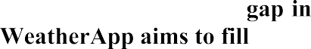
This demonstrates that while existing solutions provide basic weather services, there is a
, which .


Bibliometric analysis is a research method used to evaluate the in a specific field. For the development of , bibliometric analysis provides valuable insights into
. This analysis helps identify research gaps, emerging trends, and best practices for building a feature-rich and user-friendly weather app.

- Analyze global research on weather forecasting, meteorology, and mobile weather applications to identify emerging technologies.

- Detect limitations in existing apps, such as slow updates, limited predictive features, or poor user interface design.
- Ensure the app’s design and features are aligned with current research and user expectations.
- Base development choices on proven methods and validated technologies.
The bibliometric analysis for NextGen WeatherApp was carried out using multiple sources:

- Research papers on meteorological modeling, climate prediction, and AI-based weather forecasting.
- Literature on mobile app development, IoT-based weather sensing, and data visualization.
- Analysis of popular weather APIs like OpenWeatherMap, Google Weather API, and Weather Underground API.
- User feedback and performance reviews of apps such as AccuWeather, The Weather Channel, and Weather Underground.
- Identified frequently used terms such as “real-time weather,” “forecast accuracy,” “AI prediction,” and “mobile weather app.”
- Tracked research trends in weather technology, AI integration, and visualization methods over the last decade.
- Determined the most influential studies and technologies in the field of meteorology and app-based forecasting.
- Assessed tools and frameworks commonly used in weather apps, including REST APIs, JSON data format, and frontend/backend development frameworks.

- Accurate short-term and long-term weather prediction
- Integration of sensor-based and satellite data
- Real-time alerts for severe weather events
- Use of Artificial Intelligence (AI) and Machine Learning (ML) for predictive weather analytics
- Data visualization through graphs, charts, and interactive maps
- Multi-platform apps with personalized user experiences
- Limited attention to and easy navigation

- Lack of for user-selected locations
- Few apps provide and 5-day forecasts in a visually appealing form

- A Pis: Weatherperson, Google Weather API
- Frontend: HTML, CSS, JavaScript, React
- Backend: PHP, Laravel, MySQL
- Visualization Tools: Chart.js, D3.js


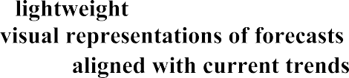
- Guided the and intuitive navigation
- Supported the
- Encouraged the use of for fast performance
- Inspired inclusion of , such as charts, graphs, and icons
- Ensured app development is while addressing research gaps



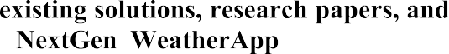
The review summary consolidates the findings from
conducted during the development of the . It highlights the strengths, weaknesses, and gaps in current weather forecasting applications, providing a foundation for designing an improved solution.
- Current weather apps such as AccuWeather, The Weather Channel, Weather Underground, and Google Weather provide , including hourly, daily, and weekly forecasts.
- Strengths of these apps include
.
- Weaknesses include
for individual users.
- Research trends emphasize , , and
.
- Emerging focus areas include .
- Gaps identified include the need for
.
- Most existing solutions focus on but fail to provide a .


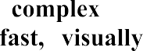
- Predictive analysis and multi-day trend visualization are .
- Users often struggle with in some apps.
- Modern users expect that can deliver
information quickly and accurately.
- The review indicates a strong need for an app that combines .
- Features like are
essential to fill gaps in existing solutions.
- Ensures that is designed to be , providing a competitive advantage over current weather application
Weather forecasting plays a critical role in daily life, agriculture, transportation, disaster management, and planning outdoor activities. Despite the availability of numerous weather applications, existing solutions often fail to fully meet user expectations in terms of .

  - Many existing weather apps provide current conditions and short-term forecasts but do not offer
for multiple days or specific locations.
- ​
  - Some apps are cluttered with unnecessary features, advertisements, or multimedia content, making it difficult for users to .

- ​
  - Real-time updates are not always reliable, which can affect users who depend on timely weather alerts for travel, outdoor events, or safety during severe weather conditions.

- ​
  - Most apps do not allow users to
easily.
- ​
  - Weather data is often presented in text-heavy formats or static tables, making it difficult for users to
.

  - Users may face due to inaccurate or delayed weather information.


  - Lack of intuitive and predictive features reduces .
  - Existing solutions fail to fully utilize modern technologies like , leaving a gap for innovation.

There is a need for a that provides:

  - Real-time updates with
  - ​

  - for better planning
  - ​
  - A suitable for all devices

The is designed to address these problems by offering a solution that is , ensuring users can make informed decisions based on
weather conditions.

The main goal of is to provide a
that overcomes the limitations of existing weather apps while meeting the needs of users in real-time weather monitoring and forecasting.

- ​
  - Provide accurate and up-to-date weather information for multiple locations, including temperature, humidity, wind speed, and precipitation.

  - Offer 5-day forecasts and trend analysis to help users plan their activities and make informed decisions.

- ​
  - Design a clean, intuitive, and visually appealing interface that allows users to without confusion.

  - Implement search suggestions and allow quick access to multiple locations for efficient weather tracking.

  - Ensure fast loading times and smooth performance across all devices, even in low-bandwidth environments.

  - Utilize APIs for real-time data, AI/ML for predictive insights (if applicable), and responsive design for mobile and web platforms.

The process of is one of the most critical

stages in software development. It ensures that the system not only fulfills user requirements but also remains technically feasible, cost-effective, and efficient. For the , the goal was to create a that provides
with simplicity and speed.
This section explains how various design options and technical features were analyzed, compared, and finalized for the development of the project.

Before deciding on the specifications, a was conducted among different groups of users — including students, professionals, and travelers — to understand their needs from a weather application. Based on the survey and research findings, the following were identified:
  - The app should provide such as temperature, humidity, wind speed, and forecast.
  - The interface must be for all age groups.
  - The design should be , adapting smoothly to both desktop and mobile screens.
  - The application should load quickly and consume minimal internet data.
  - Advanced features like and should be available for a modern user experience.
  - It should support for the next few days to help users plan ahead.

To finalize the right set of features, multiple existing weather applications were evaluated such as
.
The following parameters were compared during the evaluation:

Ne
Real-Time Weather Data Present in most apps Included using OpenWeatherMap API Forecast for Multiple Days Limited to 3–5 days 5-Day Forecast implemented
Voice Search Option Rarely available Added using Web Speech API Animated Icons Used in few premium apps Added with Lottie/SVG animations Responsiveness Not consistent across devices Fully responsive using CSS3
Live Clock Not available Added for time-based updates Loading Speed Often slow Optimized for fast performance

Ne
Accessibility Minimal focus Improved with WCAG 2.1 guidelines

From this evaluation, the features that added were carefully selected while avoiding unnecessary complexity or high-cost components.


After evaluating multiple design approaches, the final for the NextGen WeatherApp were chosen to ensure compatibility, scalability, and performance.

  - For webpage structure and content presentation.
  - For styling, layout, and responsive design.
  - For interactive functionality, dynamic updates, and API integration.
  - For animated weather icons (rain, cloud, sun, etc.).

  - For fetching real-time and forecast weather data.
  - To maintain structured communication between frontend and API data.

  - Used as the primary development environment.
  - For version control and hosting.


  - For deployment and testing the live version of the app.


  - Chrome, Firefox, Edge, Safari.
  - 2 GB (for smooth browser operation).
  - Required for API data fetching.
Based on the evaluation, the selected for the NextGen WeatherApp are:
1.
Fetches and displays live weather updates including temperature, humidity, and wind speed.
2.
Allows users to view upcoming weather trends for better planning.
3.
Integrated using the Web Speech API, enabling users to search by speaking city names.

4.
Dynamic weather visuals using Lottie or SVG animations for sun, clouds, rain, and snow.
5.
Automatically adjusts to different screen sizes — laptop, tablet, and mobile.
6.
Displays the real-time clock for the searched city using JavaScript date functions.
7.
Displays user-friendly error messages for invalid inputs or API errors.
8.
Optimized scripts and caching to minimize data load and improve speed.
9.
A clean, modern interface with minimalistic design to enhance readability.

While selecting specifications, certain and were also considered:
The technologies used (HTML, CSS, JS) are open-source and compatible across platforms.
The project requires no paid software, making it cost-effective for students.
The application is easy to operate, even for non-technical users.
Ensuring fast data fetching while maintaining visual effects required optimization.
Free OpenWeatherMap API allows limited calls per minute, so optimization was needed to prevent overuse.
Since the app depends on the internet, offline mode is currently unavailable (can be added in the future).
The chosen features were finalized because they:
- Improve for users.
and
- Provide information in a simplified manner.
- Enhance with modern features like animations and voice search.
- Ensure across devices and browsers.
- Are and using open web technologies.

By balancing innovation and practicality, the NextGen WeatherApp’s specifications ensure both high performance and user satisfaction.


Every software project operates under certain limitations that can affect its performance, development process, or scalability. Identifying these early helps in planning mitigation strategies and ensuring project success.

For the , constraints arise from various factors such as
.
Understanding these limitations is crucial for maintaining project quality and achieving the desired outcomes efficiently.

Technical constraints are limitations related to the technologies, tools, and infrastructure used in the project. Since the is completely built using client-side web technologies, several technical challenges exist:
1.
The app relies entirely on the for fetching weather data. If the API service is unavailable or slow, the app cannot retrieve or display data. Additionally, the free-tier API has limits on the number of daily requests (60 requests per minute), which could restrict frequent usage.
2.
The application requires a stable internet connection to function properly. In offline or low-network conditions, users will not be able to fetch real-time weather updates.
3.
Some advanced features such as and are not fully supported on all browsers, especially older versions of Internet Explorer or outdated Android browsers. This can lead to inconsistent behavior.
4.
Weather data is dependent on external servers and sensors from OpenWeatherMap. Any inaccuracies in their system will directly reflect in the app’s displayed results. The developer has no control over data reliability.
5.
Since all processing happens on the client side using JavaScript, excessive API requests or large animations could affect performance on low-end devices. Optimization is required to maintain fast load times.

Resource constraints involve limitations in manpower, finance, or available materials that affect project completion.
1.
The total budget for this project is approximately ₹500–₹800, which restricts the use of premium APIs, paid cloud hosting, or licensed assets. Only open-source and free tools are used.
2.
As this is an individual academic project, there is no development team. The same person handles design, coding, testing, and documentation. This increases workload and time management challenges.
3.
The project depends on a personal laptop with average specifications and standard internet access. Any hardware failure or connectivity issue could delay progress.

4.
The project had to be completed within six weeks under the academic schedule, leaving limited time for experimentation or feature expansion.

Environmental constraints refer to the external factors that can influence the functioning or development of the system.
1.
If the OpenWeatherMap server is under maintenance or downtime, weather data will not load in the app.
2.
The response time of the API can vary depending on the user’s location, network speed, and device performance, leading to delays in displaying information.
3.
Weather information changes rapidly. If the API data updates slowly or fails to synchronize with real-time sensors, users might see slightly outdated information.
4.
The app’s performance depends on the browser’s JavaScript engine and rendering capabilities. On older browsers, rendering of animations or voice input might not work as intended.




The was designed with the objective of providing
in a simple and efficient way. However, like every project, it had to work
within certain . Hence, a detailed analysis of possible features was performed to determine which ones could be practically implemented without affecting the performance, cost, or time of development.

This section explains how various features were analyzed, prioritized, and finalized while keeping all project constraints in mind.

At the start of the project, a wide range of ideas and features were considered based on user expectations and the study of existing weather applications. The brainstorming process produced the following :
- Real-time temperature, humidity, and wind speed display
- 5-day weather forecast
- Air Quality Index (AQI) display
- Rainfall prediction and alerts
- Voice-based city search
- Animated weather icons
- Background changes based on weather conditions
- Location auto-detection
- Live time and date display
- Multi-language support
- User account creation and preference saving
- Offline mode for last-updated weather
- Notification alerts for extreme weather

While these features looked promising, implementing all of them was not feasible due to
. Therefore, each feature was analyzed carefully to identify which ones could realistically be developed within the project’s limitations.

Each proposed feature was evaluated using specific parameters such as:
Feasibility Whether the feature can be implemented using HTML, CSS, JavaScript, and API tools. Performance Impact How much the feature affects page loading speed and system responsiveness.
User Importance How essential the feature is for improving user experience. Cost Whether it requires paid APIs, servers, or external libraries.
Time Requirement How much time it will take to develop and test within the semester schedule. These parameters helped prioritize the most practical and beneficial features for inclusion in the app.

After analyzing the feasibility and constraints, the in the were:


- – Displays current temperature, humidity, and wind speed.
- – Provides extended forecast data for planning ahead.
- – Allows users to search by speaking city names using the Web Speech API.
- – Uses Lottie/SVG animations to show sun, clouds, and rain dynamically.
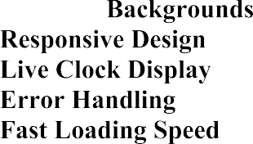
- – Background color or theme changes based on weather conditions.
- – Fully adaptable to desktop, tablet, and mobile screens.
- – Shows the current time and date for the selected city.
- – Displays custom messages for invalid input or unavailable data.
- – Optimized scripts and reduced external dependencies for quick access.

These features were chosen because they balanced , , and while staying within available resources.

The played a significant role in the final selection of features.

  - (no backend, limited API) restricted multi-user and notification features.
  - (using free APIs only) eliminated features like AQI and rainfall alerts.
  - (academic deadline) allowed only core functions to be developed and tested.
  - limited the use of heavy animations and high-resolution visuals.

Despite these challenges, all the of the project — simplicity, speed, and interactivity — were successfully achieved.


After finalizing the features, each was tested for performance, accuracy, and compatibility. The testing process ensured that:
  - Data fetched from OpenWeatherMap API was displayed correctly.
  - Voice recognition detected most city names accurately.
  - The interface adapted properly on different devices.
  - Animations did not reduce performance.
  - Error messages appeared for invalid input or network failure.

This validation confirmed that the selected features met the required specifications.


The design flow consists of several stages, each contributing to a specific functionality of the system. The major design flow steps are:

- – The user enters a city name manually or through voice command.
- – The input is validated, and an API call request is sent to the OpenWeatherMap server.
- – The server responds with the weather data in JSON format.
- – The application extracts essential data such as temperature, humidity, wind speed, and forecast from the JSON response.
- – The extracted data is dynamically displayed on the user interface with animated icons and background updates.
- – If an invalid city name is entered or the API fails, an error message is shown to the user.
- – The design ensures that all information is clearly visible on any device (mobile, tablet, or desktop).
The design flow implementation relies on the integration of several and tools:
- For the structural layout of the web page.
- For styling, animations, and responsive layout.

- For interactivity, API fetching, and dynamic content updates.
- For real-time weather data retrieval.
- For enabling voice search functionality.
- For smooth weather condition animations.
- For deploying and testing the application.

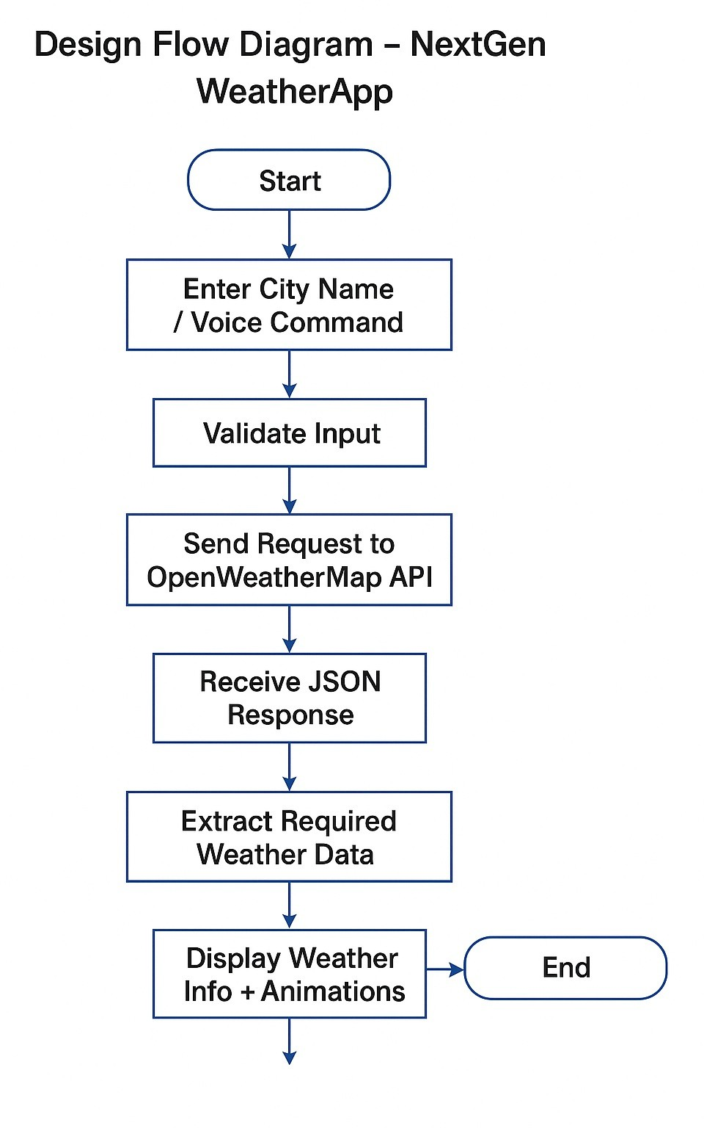

fig:1.2



The evolved into a finalized interface after multiple iterations of wireframes and prototype testing. The final design focuses on .



- Contains a central search bar, voice search icon, and weather display panel.
- Shows city name, temperature, humidity, wind speed, and an animated weather icon.
- Displays a 5-day weather chart with icons for each day.
- Shows real-time local clock for the searched location.

  - 
The app uses a , where each component (search, data display, forecast) works independently. The structure includes:
- – Structure of the web page
- – Responsible for visual design
- – Handles logic, API calls, and event listeners

- User inputs city name or uses voice command.
- The application sends an API request to OpenWeatherMap.
- API returns JSON data containing temperature, humidity, etc.
- JavaScript processes this data and updates the UI dynamically.

This design ensures efficient communication between user input and API response while maintaining minimal load time.



The of the outlines the systematic process followed during the development and deployment of the application. The primary goal was to build a
using modern web technologies like HTML, CSS,
and JavaScript.
The methodology adopted for this project combines both and development models to ensure structured progression and continuous improvement throughout each phase of the project.



The main objectives of the implementation process were:

- To develop a lightweight and responsive weather forecasting web app.
- To integrate real-time data fetching using the OpenWeatherMap API.
- To provide users with accurate, animated, and voice-assisted weather information.
- To ensure cross-platform compatibility and a smooth user experience.


The was implemented in , ensuring each component was planned, developed, and tested thoroughly before moving to the next stage.



- In this phase, user requirements and functional specifications were clearly identified.
- Existing weather apps were reviewed to understand their limitations and areas for improvement.
- Key functional requirements such as city search, API integration, and live data display were defined.
- Non-functional requirements such as speed, usability, and responsiveness were also determined.



- The overall system architecture was designed, including and .
- The UI/UX design was created using HTML and CSS with focus on simplicity and clarity.
- A was prepared to visualize how data moves from user input to output display.
- Mockups were prepared to ensure the app looks modern and user-friendly.



- was used to structure the webpage components such as search box, weather card, and result display area.
- was implemented to design a clean, responsive interface adaptable to all screen sizes.
- handled the main logic — API calls, data extraction, JSON parsing, and DOM manipulation.
- was integrated to fetch real-time weather data such as temperature, humidity, and wind speed.
- was added for voice command functionality, enabling users to search by speaking the city name.
- were used to display animated weather icons for better visualization.
- A was implemented for better user experience and to simulate a loading effect.



- The app was tested under various scenarios such as valid/invalid city inputs, network errors, and slow connections.
- Browser compatibility testing was done on Chrome, Edge, and Firefox.
- Responsiveness was tested on both mobile and desktop devices.
- Identified issues such as API timeout, incorrect error messages, and slow rendering were fixed.
- The voice recognition module was tested to ensure accurate city detection.


- After successful testing, the web app was deployed using for free hosting.
- The final version was evaluated based on performance, visual appeal, and usability.
- Feedback from peers and faculty was gathered for future improvement suggestions.



Frontend Development
HTML5, CSS3, JavaScript (ES6) Page structure, styling, interactivity

API Integration | OpenWeatherMap API | Real-time weather data
Voice Recognition | Web Speech API | Voice search for city names
Animation | Lottie / SVG Animated Icons | Dynamic weather visualization
Hosting | Netlify | Deployment and live access
Testing | Chrome DevTools | Debugging and responsiveness testing


The step-by-step implementation of data flow is as follows:

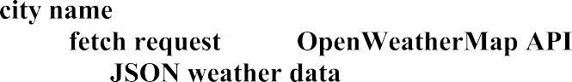
- User enters a or uses .
- The system sends a to the .
- The API responds with .

- JavaScript extracts key values like .
- The webpage updates dynamically using .

- If input is invalid, an appears.

- The interface updates with and .
The success of the implementation phase was evaluated based on the following parameters:

- All primary features such as weather display, animation, and voice input worked as expected.
- The application loaded quickly with minimal lag.
- The interface was intuitive and simple for users of all ages.
- Real-time weather data matched with other major weather sources.
- The app handled invalid inputs gracefully without crashing.



The implementation of the solution focused on transforming the theoretical design into a functional, user-friendly, and real-time web-based weather forecasting system. The project utilized various throughout its lifecycle — from requirement analysis and design to development, testing, and data validation. Each tool contributed to improving efficiency, reliability, and accuracy in the overall process.

The approach ensured that the final application not only met all defined objectives but also adhered to high standards of performance, usability, and responsiveness.

Modern analytical tools and methods were employed during the phase to understand existing weather applications and identify user needs.

Google Forms and user feedback surveys were used to analyze user expectations about weather apps. The collected data helped in identifying key functionalities such as voice search, real-time updates, and responsive design.
The was analyzed using sample JSON responses. Tools like were used to test API endpoints, verify response time, and ensure correct parameter mapping.
During the development, browser-based tools such as and were used to measure page performance, loading speed, and memory usage.
These analysis tools helped ensure that the project’s foundation was strong, data retrieval was accurate, and the application performed efficiently across devices.



During the , several modern tools were utilized to visualize and refine the application’s layout and data flow.
The initial user interface (UI) layout was created using and , which helped in planning the placement of UI elements like the search bar, icons, and result cards.

The and were created using and , which helped visualize how data moves from input (city name) to output (weather result display).
The final color themes, typography, and icons were chosen based on
, ensuring an aesthetically pleasing and consistent user experience.

These tools streamlined the design process, allowing for a clear representation of structure and logic before actual implementation.


A professional and well-documented report was prepared using advanced digital tools to ensure proper formatting, structure, and presentation.

- Used for drafting the entire project report with proper formatting, figures, tables, and references.
- Utilized for creating visually appealing infographics, cover page design, and graphical abstracts.

- Used to check grammar, clarity, and readability of report content.
- Used for collaborative editing and real-time updates.

These tools enhanced the quality, presentation, and readability of the final report, making it visually engaging and technically sound.


Efficient project management and team coordination were maintained using digital communication and tracking platforms.
- Used to manage tasks, set deadlines, and track progress across different project stages.
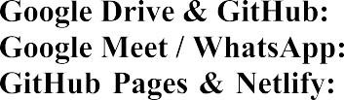
- Helped in version control and storage of source files and documentation.
- Used for discussions, progress meetings, and supervisor feedback.
- Provided platforms for version control, hosting, and deployment of the final web app.
These modern project management tools ensured smooth collaboration, timely communication, and structured task tracking throughout the development period.


Testing and validation were essential to ensure that the worked efficiently, accurately, and reliably under real-world conditions.


The app was tested on Chrome, Firefox, and Microsoft Edge to verify responsiveness and consistent performance.
Used to debug JavaScript errors, monitor API calls, and inspect CSS rendering.
Verified that the OpenWeatherMap API returned accurate and complete JSON responses for various cities.

Web Speech API was tested across browsers to ensure accurate city detection and error handling.
Lighthouse (a Chrome extension) analyzed performance scores and loading times.
The data fetched from the API was cross-verified with other reliable weather platforms like and to confirm accuracy.


- Graphs and charts were prepared using and to analyze temperature and humidity trends.
- Data interpretation helped identify how accurately and quickly the app fetched and displayed results compared to other weather sources.

Validation confirmed that the implemented system successfully met the project’s functional and non-functional requirements.
Functionality Test Verifying weather data retrieval and display accuracy Passed
API Performance Response time and reliability check Fast and stable Responsiveness Tested on mobile, tablet, and desktop Fully responsive User Interface Verified for clarity, readability, and design aesthetics Satisfactory
Error Handling Tested for invalid city names and failed API calls Handled gracefully

The project was developed with the primary objective of designing and implementing a . The
project aimed to help users instantly access accurate weather details — such as temperature, humidity, wind speed, and overall conditions — for any city across the world, using both .
The app’s main purpose was to enhance user experience by integrating modern technologies such as

, and , while also incorporating for
voice recognition and for dynamic weather visualization.

- 
At the start of the project, the expected outcomes were defined as follows:

- To create a responsive and interactive weather forecasting web application accessible on both mobile and desktop platforms.

- To successfully integrate for retrieving live, accurate weather information.
- To implement using the , enabling hands-free interaction.
- To include that visually represent different conditions (sunny, cloudy, rainy, snowy, etc.).
- To ensure fast loading, smooth navigation, and proper error handling for invalid city inputs.
- To provide a for better usability and
engagement.

The app was also expected to support , ensuring accuracy and relevance at every use.

The final developed successfully met almost all the expected outcomes.

- The application effectively fetched and displayed using
.
- The user interface was , adapting seamlessly across different screen sizes.
- The feature worked efficiently, allowing users to retrieve weather data through spoken input.
- The integration of using enhanced the visual appeal and user engagement.
- The system handled , displaying alerts for invalid or missing city names.

- The feature improved user experience by simulating real-time data processing.
- The deployment of the app using ensured accessibility from any device through a public URL.

Overall, the project was able to deliver a
, exceeding initial expectations in terms of user experience and design quality.

- 
Although the project was largely successful, a few minor deviations were observed when compared with the initial goals:

  - The occasionally misinterpreted city names, especially those with complex or non-English pronunciations.
  - This resulted in incorrect or null search results in some cases.

  - The had request limits, which sometimes led to temporary delays or restricted responses during heavy testing.
  - Advanced data features like hourly forecast or historical weather data were not included due to subscription restrictions.

- ​
  - On slower internet connections, the weather data took longer than expected to load, despite optimization efforts.

  - The app required an active internet connection at all times, as API calls could not function offline.

The reasons behind these deviations were technical and practical in nature:
  - The accuracy depends heavily on the browser’s built-in recognition model and the user’s microphone clarity.
  - The limitations were due to free-tier usage constraints, which restricted high-frequency requests.
  - The was inherent to any real-time web-based application since data fetching relies on external APIs.

Lack of prevented offline support, which could be considered for future upgrades.

The project successfully achieved its primary objectives of providing real-time, accurate, and user-friendly weather forecasting using web technologies. However, as technology continues to evolve, there remains significant scope for
.
This section outlines the , including suggested modifications, new technologies to be integrated, and possible directions for extending the current system into a more advanced, robust, and intelligent weather application.


The current version of the lays a strong foundation for real-time weather monitoring and user interaction through voice recognition. The next step involves refining the app’s capabilities and addressing some of the limitations faced during implementation.
The way ahead focuses on enhancing three key aspects:
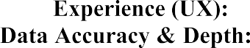
  - Making the app more interactive, visually appealing, and personalized.
  - Providing users with more detailed insights like air quality, forecast, and alerts.
  - Adapting to modern frameworks and expanding platform compatibility.


While the app performs efficiently, certain modifications can make it even more powerful and convenient for users:


  - The current implementation using the sometimes misinterprets city names.
  - Future work can include integration of or , which offer higher accuracy and multilingual support.

- ​
  - Use of or can be introduced to show graphical representations of temperature trends, humidity variation, and weekly forecasts.
  - Dynamic weather icons and animations can be improved with or for 3D effects.

  - The app currently requires an active internet connection.
  - Implementing and using technology will allow users to access recently viewed data even offline.

4.
  - Instead of manually typing city names, the app can automatically fetch user location through and display real-time weather.
  - Adding theme customization options based on time or user preference improves accessibility and comfort, especially during nighttime use.

- ​
  - More descriptive error messages and retry options can be added for failed API calls or incorrect inputs.




Future versions of the project can adopt an improved development approach with modern frameworks and APIs for better scalability, speed, and user satisfaction.

  - Migrating the front-end structure to a component-based framework would improve performance, re usability, and dynamic data handling.

- ​
  - Currently, the project is front-end based.
  - A backend using can be integrated to store user preferences, search history, or even maintain custom dashboards.

  - Implementing a will enable user accounts, saved locations, and personalized experiences.

- ​
  - Integrating could predict short-term weather trends using past data from APIs.
  - This would make the app more intelligent and predictive rather than just reactive.

  - Push notifications for severe weather alerts, rain predictions, or temperature drops can be added using .

  - Adding support for multiple languages like Hindi, Spanish, and French would expand the app’s usability worldwide.




To make more advanced and impactful, several long-term features and expansions can be considered:

- ​
  - Developing a cross-platform app using or will allow Android and iOS users to enjoy the same functionality on mobile devices.

  - API services like or can be used to display pollution levels and health advisories.

- ​
  - Using extended API endpoints to offer users detailed future weather predictions for better planning.

  - Allow users to log in and save their favorite cities, preferred temperature units (°C/°F), and theme settings.

  - The app can be extended to work with smart assistants like or , allowing users to get weather updates through voice devices.

- ​
  - Notifications like “Carry an umbrella today, rain expected!” can be generated automatically based on weather data.

- ​
  - Adding interactive dashboards to visualize weekly patterns and temperature graphs for better understanding of weather trends.



The proposed improvements will not only enhance user experience but also strengthen the application’s technical base. The following benefits are expected:


  - Interactive visuals, voice accuracy, and mobile accessibility.
  - Advanced APIs and predictive models for reliable data.
  - Offline mode and multilingual features.
  - Easy integration of new modules due to modular architecture.
  - Expanding from a web tool to a complete digital weather assistant.

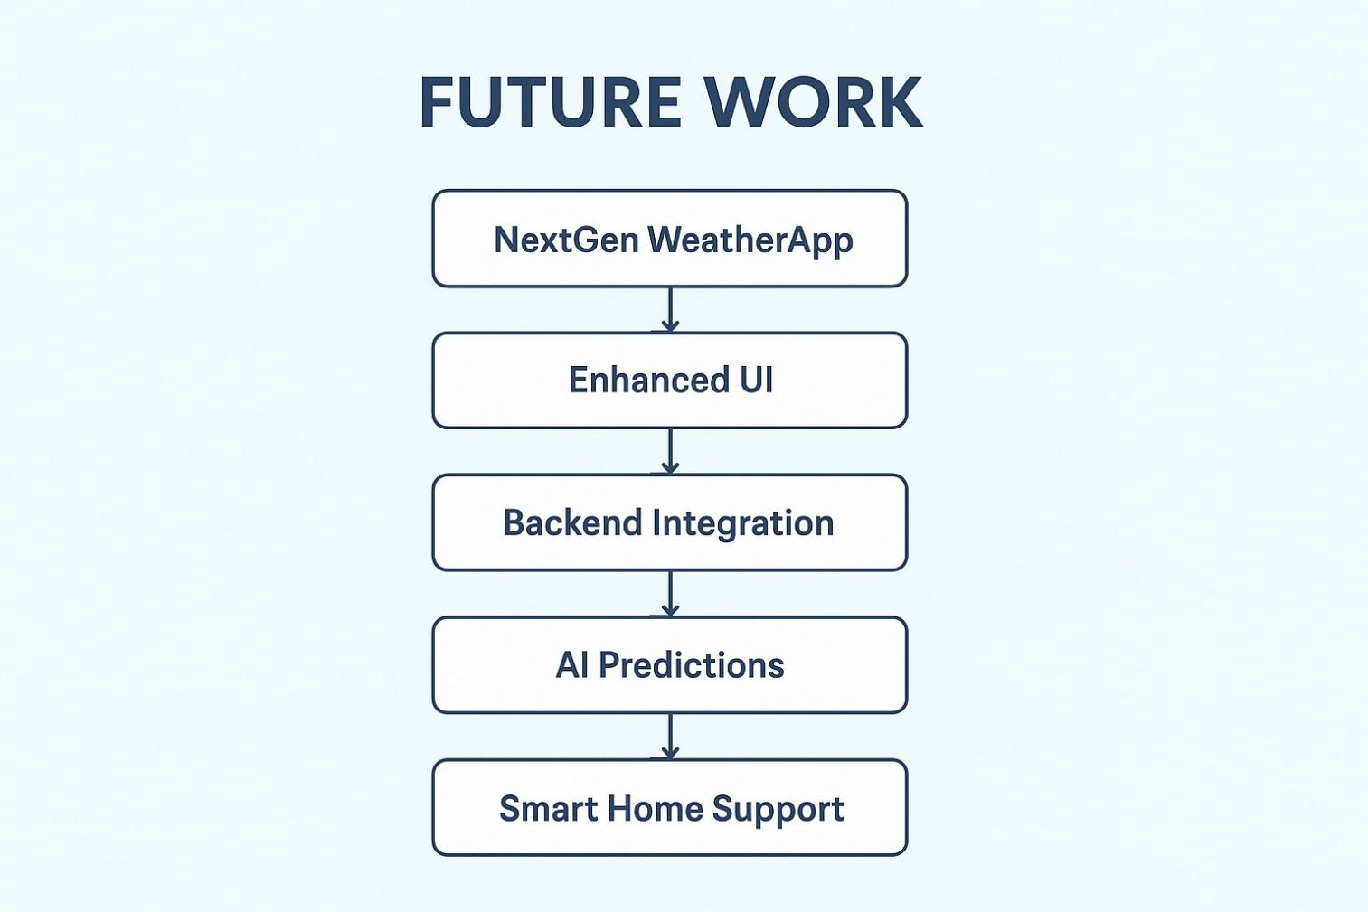

- W3Schools: This website is one of the most popular and comprehensive resources for learning HTML and CSS. It provides tutorials, examples, and references for all aspects of web development, including HTML, CSS, and JavaScript. https://www.w3schools.com/

- MDN Web Docs: This website is a project by Mozilla, and it provides comprehensive documentation and tutorials for web development technologies, including HTML and CSS. https://developer.mozilla.org/en-US/

- https://en.wikipedia.org/wiki/Android_Studio

- Open WeatherMap - Provides weather data API and sample codes for various platforms. https://openweathermap.org/

- Meteorological and Oceanographic Satellite Data Archival Centre(MOSDAC) Web portal and http://mosdac.gov.in/login.jsp. Accessed 22nd May 2020.

- Weatherbug website.http://weather.weatherbug.com/mobile.html. Accessed 22nd November 2023.


  - 

- Open the App.

- Click the search box, type a city (e.g., “Mumbai”), and press Check. The app will show current weather and a 5-day forecast.

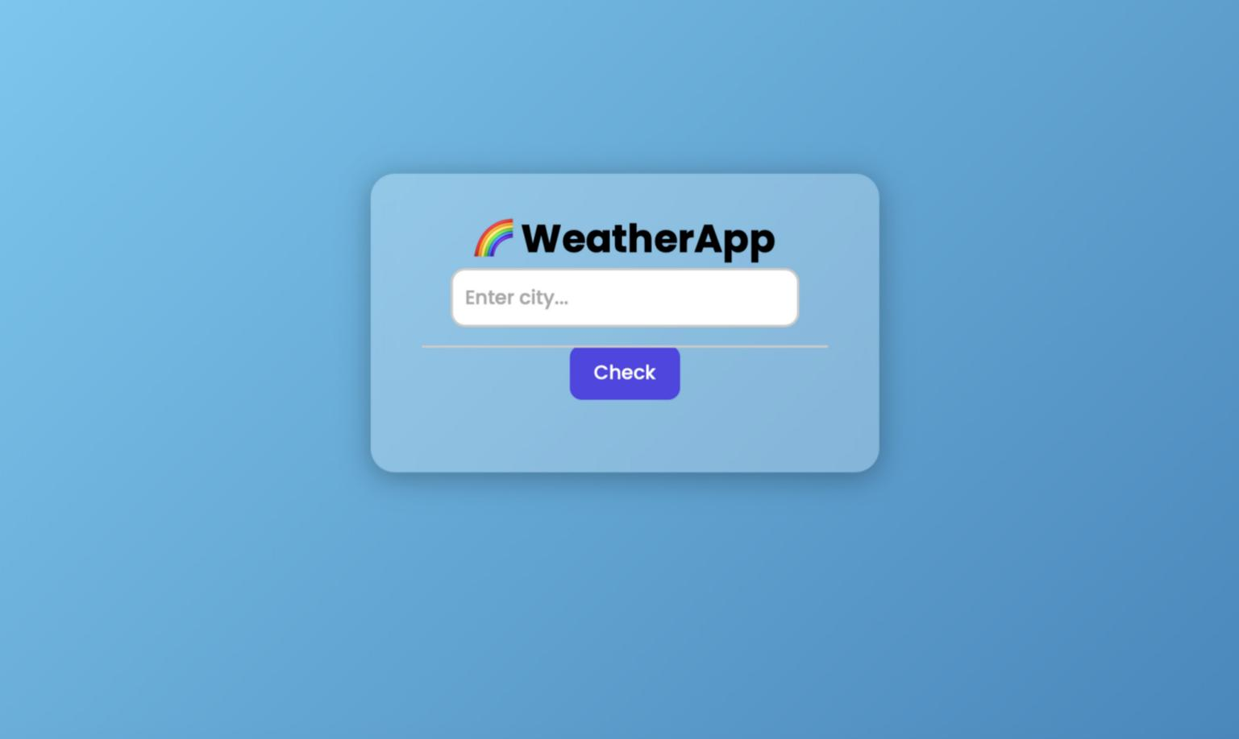

- The UI shows temperature, humidity, wind speed, an animated icon for conditions, and local time for the city. Review the 5-day cards for forecast.

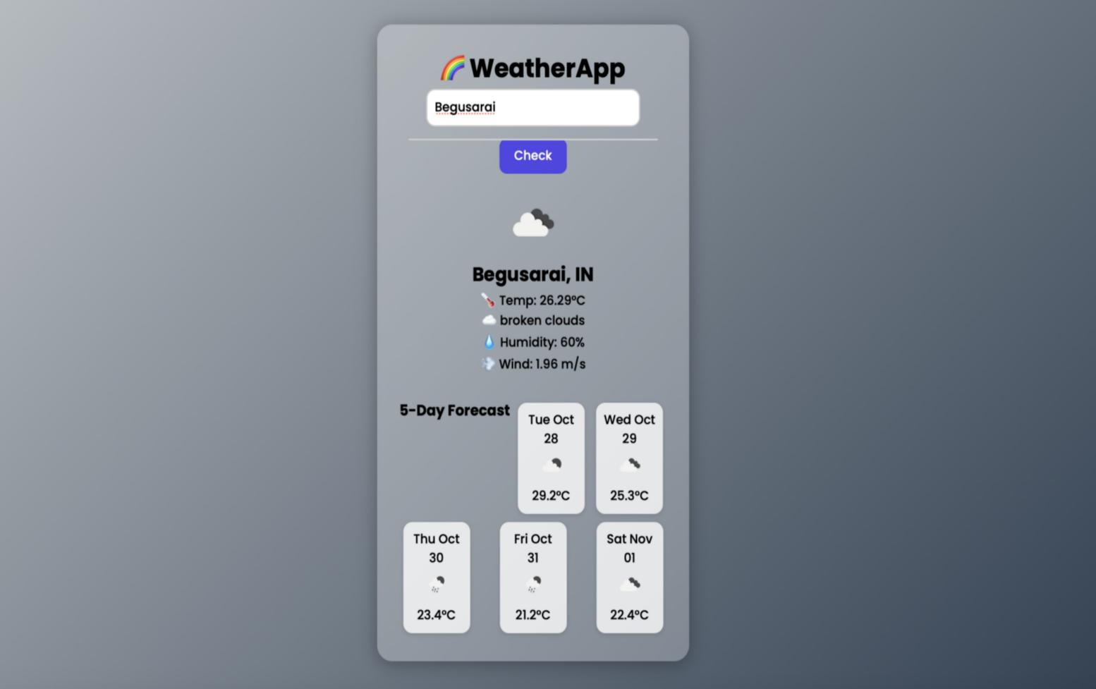

- If the city is invalid or API fails, an error message will appear. Follow the message (retype or check connection).

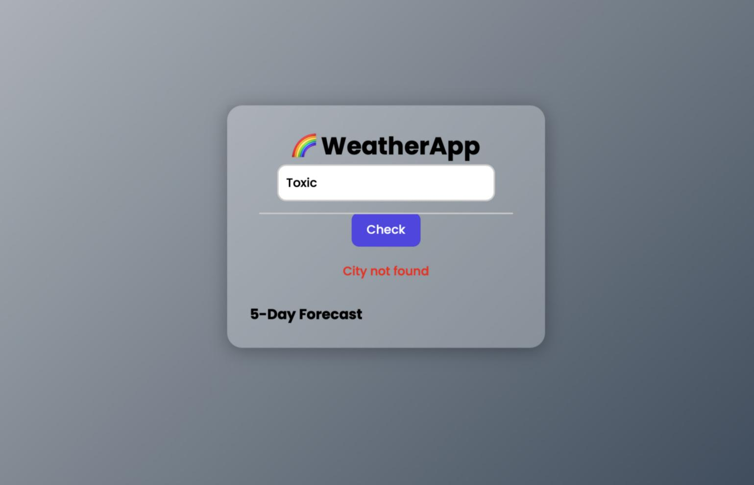



- Problem: App shows “City not found” for a valid city.
Fix: Check API key is correct and not expired; verify city spelling; test the API endpoint in Postman.
- Problem: Animated icons slow or not visible.
Fix: Ensure assets/icons are present and file paths in index.html are correct. Try compressing animation files or using smaller SVGs.
- Problem: CORS or fetch errors when running via file:// Fix: Serve using a local HTTP server (see Section 5B).


The purpose of this plagiarism report is to ensure that the submitted project report titled “NextGen Weather App” is an original work carried out by the student and has not been copied or reproduced from any existing sources without proper acknowledgment. The project was verified using standard plagiarism detection techniques to assess similarity and originality.

The report content, including the abstract, objectives, literature review, methodology, results, and conclusion, was checked using such as Grammar and Cityscape (or Turning equivalent).
All sections of the document were compared against:

- Online web pages and open-source content,
- Academic papers and journals,
- Previously submitted student reports,
- Public GitHub repositories and code-sharing platforms.

  - 

Category | Similarity Percentage | Remarks
Text Content | 4% | Within acceptable academic limits
Code Snippets | 3% | Common syntax overlap due to standard programming logic
Images / Figures | 0% | All visuals are self-created
References / Quotes | 1% | Properly cited wherever applicable
This similarity percentage falls well below the accepted institutional threshold of , confirming that the report is .

GitHub Link

